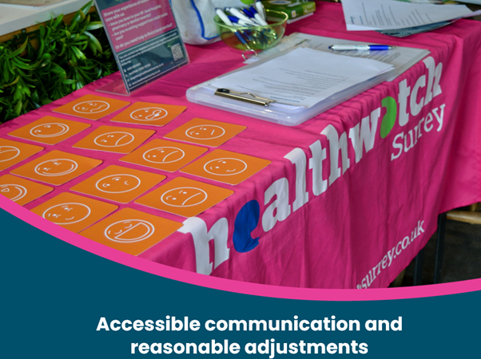

Background
Accessible communications and reasonable adjustments
August 2025

In August 2025, we provided a training session to a GP practice regarding accessible communications and reasonable adjustments highlighting examples based on lived experience.

Further info coming soon!
Please get in touch if you are keen to find out more now!

