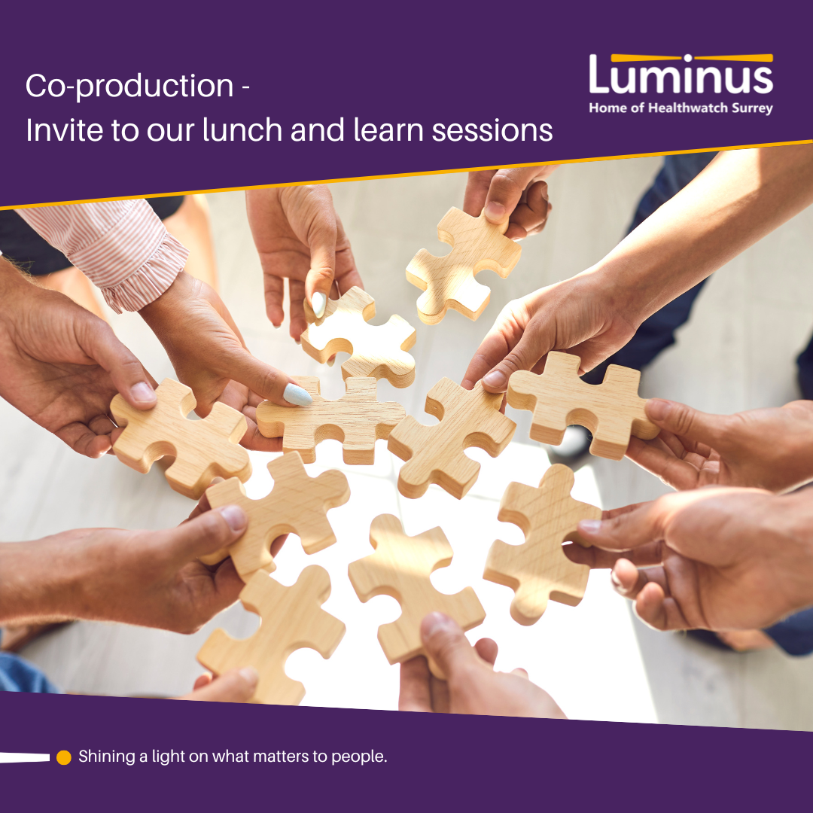

Background
Co-production lunch and learn session
November 2024

In November 2024, we held two sessions about co-production:
- Understanding co-production
- Co-production in practice.

The sessions were held by Becki Meakin, Research Manager at Luminus, who has extensive experience of designing and delivering co-production with disabled people, people from marginalised communities and the general public.

Further info coming soon!

Please get in touch if you are keen to find out more now!

