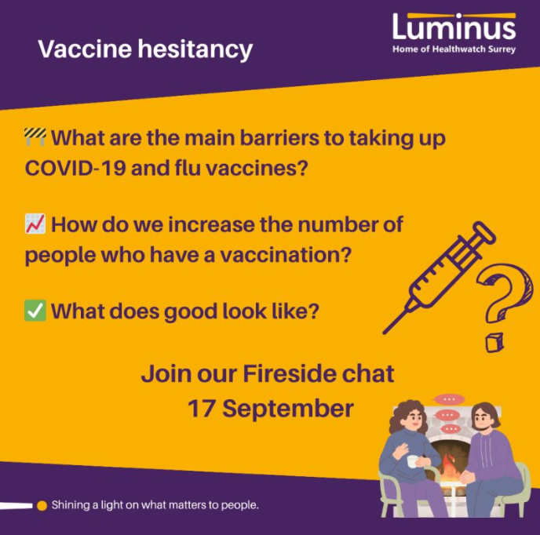

Background
Vaccine hesitancy – fireside chat
September 2025

In September 2025, we held a fireside chat to hear the main findings and recommendations from our 3 research studies relating to vaccinations.

Further info coming soon!

Please get in touch if you are keen to find out more now!

