How can we help? Prevention

Luminus’ vision is ‘a society where everyone’s voice is heard, so we all receive the support we need for our wellbeing’.

We understand that prevention and early intervention services help people avoid ill health or identify problems early to prevent them from worsening, benefitting not only patients, but also reducing the demand for care. Indeed, The NHS Ten Year Plan sets out an ambitious agenda for healthcare in England, with prevention of ill health and early intervention as central pillars. (From the Healthwatch England report: What are people telling us about prevention and early intervention?). Our belief is that to work effectively, preventative services need to be built on a solid foundation of robust insight into behaviours and potential barriers, and co-designed with communities from an early stage.

As Luminus, we support the priorities of Surrey’s Health and Wellbeing Strategy regarding prevention and the wider determinants of health in a number of ways:
- Across all our work - Healthwatch Surrey, Giving Carers a Voice, Combating Drugs Partnership Public Involvement and our Community Voice Projects - we speak to people about their experiences of local services, and turn these insights into actionable recommendations, to ensure these are taken into account in the design and delivery of services.
- We speak to people about the support that is available for their health and wellbeing and signpost them to relevant services. We also help professionals identify which support services might be helpful for their patients/service users.
- We highlight to service providers how they can make their services more accessible to a wider audience to enable more take up of preventative services. Our volunteer Reading Panel offers practical support to partners wanting a lay critique of their literature, leaflets etc.

Some of our recent work:

Sight (eye) tests
Earlier in the year Healthwatch Surrey asked parents of school age children whether their children had sight (eye) tests and if there were any barriers to having these tests. Our subsequent report - Out of sight, out of mind: parents and carers understanding of sight tests for school aged children - July 2025 highlighted the issues which the parents of neurodivergent children in particular face.

“This experience is never easy. I have 3 children who all have special educational needs and often the staff have very little understanding of their autism and other conditions. Every time we attend, I have to request a quiet room, end of day appointment and waiting times to be minimum.”



Healthwatch Surrey developed an information resource to answer some of the questions raised by parents. The resource is supporting various system partners and is also available on the advice and information pages of the Healthwatch Surrey website - Sight (eye) tests for children and young people.

Patient information leaflets
In collaboration with Frimley Health, in July and August, Healthwatch Surrey sought patients’ views on Frimley Hospital’s information leaflets and whether the leaflets are accessible and useful. Healthwatch Surrey’s volunteer reading group also commented on these leaflets. The findings have now been shared with partners in Frimley who are using them to make their resources more accessible, easier to navigate, and better aligned with patients’ and carers’ needs.

Sexual health
The latest Sexual Health Joint Strategic Needs Assessment (JSNA) for Surrey highlighted a need to improve engagement and understanding of sexual health & contraception needs in younger people. Against this backdrop and in discussion with Public Health, Healthwatch Surrey (which has been part of the Surrey Sexual Health Outreach Group since 2019) wanted to amplify the voice of under 25s in relation to sexual health services in Surrey.

They engaged with 9 colleges through in person visits and an online survey. In total, 594 people responded.

The findings showed that although 75% of students were aware of sexual health services, this was affected by whether the college they attended ran sexual health outreach sessions.

There was also a nervousness around the self-testing kits, with people saying they wouldn’t trust themselves to do it properly and that they’d like a professional to help them.

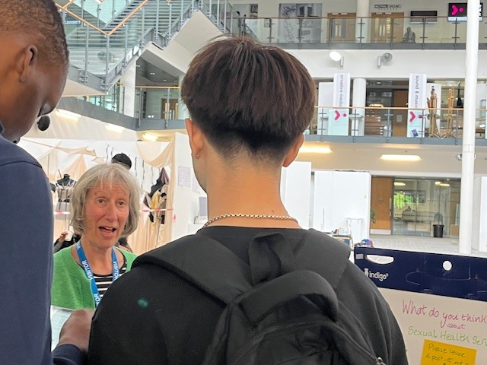

This feedback and themes have been sent and responded to by Surrey County Council’s Public Health team, including some helpful information to help people get the most from sexual health services in Surrey which have been added to Healthwatch Surrey’s Sexual health services for under 25s report.

Smoking cessation
In the last quarter (July to September) the Luminus Combating Drugs Partnership Public Involvement team have spoken to people about smoking cessation, focusing on a specific area of Surrey known to have the highest smoking levels with 3 areas of deprivation. They worked with One You Surrey and also signposted people to support, having Make Every Contact Count conversations with people where relevant.

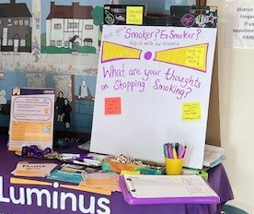
As part of the conversations, they also asked people if there was anything that would motivate them to engage with smoking cessation services.

One man said “What's the point in quitting now? The damage is done."
Male, 64 - 75, White British, Spelthorne.

However, once he had spoken to our team and they had explained some of the benefits, he said he felt differently.

One You Surrey have confirmed that following on from speaking to us, they have received some self-referrals.

Vaccine hesitancy
In September 2 members of our team held an online “Fireside chat” about vaccine hesitancy based on the learnings from 3 research studies completed this year, about why older people, people from ethnically minoritised communities and care workers are reluctant to take up a COVID-19 and/or flu vaccination or booster. The Fireside chat allowed time for discussions to take place and there was positive feedback regarding how staff from different agencies found it important and helpful to discuss findings together.

Our research about vaccine hesitancy has provided insight leading to changes in communication materials regarding eligibility, busting myths about vaccines and addressing concerns.

Our one pagers about this research: Understanding the barriers to uptake of the COVID-19 vaccination in over 75s - LUMINUS; COVID-19 vaccination uptake phase 2 - LUMINUS; Flu vaccine take-up amongst care home workers - April 2025 - LUMINUS;.

And our work continues

NHS Health Checks
As part of our Healthwatch Surrey engagements for this quarter, we are out in the community asking people aged 40 - 74 whether they have been invited to an NHS Health Check and what their thoughts are about them. To try and hear from as many people as possible, we are also running a survey. This can be completed online (Healthwatch Surrey NHS Health Checks Survey Q3 2025-6) or people can get in touch with our Helpdesk if they need a paper copy or would prefer to share their experience in their own words.

Sight (eye) tests
Healthwatch Surrey, in partnership with the Surrey Local Optical Committee (LOC), Sight for Surrey, the Specialist Diabetic Screening Service, High Street Opticians and Surrey Heartlands ICB,​ are looking to understand the barriers to having sight tests and what might encourage those from black and Asian minoritised communities to attend.​ This project is also supported with a survey which people can complete online (Experiences and barriers to accessing sight (eye) tests for Black and Asian minoritised communities) or by contacting our Helpdesk for a paper copy.

Stopping smoking – your thoughts
One of our Community Voice Projects, which will be running for a year, is working with public health to support Surrey residents, wherever they are in their stop smoking journey, to understand the risks of smoking, and when they are ready, to let them know what free support is available to help them quit. By raising awareness, we can collectively help increase referrals into the local smoking cessation service. There is also an online survey to accompany this work: Stopping smoking – your thoughts.

Prevention focus on people aged 50 – 65
We are just outlining a project which will look at prevention for people aged 50 – 65 who live in Spelthorne and also those living in Elmbridge to provide comparison. We will be running a survey and 4 focus groups (for carers, men, people with disabilities or long-term conditions, and racially minoritised communities).

